**Life Fleeting**

**Project Description**

I intend Life Fleeting to be an FPS Zombie survival game. In this game the player will race against the clock to escape the soon to be detonated city of Tore, while surviving the present zombie hoard, using whatever tools the find along the way. I intend this game to be for the more casual of gamers, who just want a bit of fun and intensity.

**Characters**

Doctor Andrews: The doctor that the player controls, responsible for the discovery and the creation of the cure that could save humanity.

Sergeant Johnson: The man instigating the detonation of the city, this character will maintain communication with the player throughout the level over a radio.

**2. Story**

The game’s story takes place in the year 2087, a zombie apocalypse has broken out worldwide. Doctor Andrews, the player’s character, is responsible for the cure which he must escort out of the city of Tore. Tore has been overrun for 6 years now, destruction of the city via detonation has been issued by the military, and Doctor Andrews is to be escorted by military convoy to the evacuation zone. At the business district things go south, the Humvee that Andrew’s was in got totalled while the lead Humvee carries on its journey as it holds the cure. Zombies approach at all sides, Andrews is the only survivor of the crash. That bomb is going off whether he’s inside or out of the city. Grabbing the rifle from one of the now deceased soldiers, Andrews must make it to the evacuation point by himself before the bombs get dropped.

**2.1 Theme**

The theme I’m going for with this game is all about the intensity of the situation that this person has been thrown into through no fault of their own. I want the game to be serious, heart racing and fast paced.

**3. Story Progression**

As the player progresses through the level of the game, they will start to see the impact this apocalypse has had on areas like this, I plan to implement the main character commenting on these sights as they go through the level.

**4. Gameplay**

Since this section can become humongous, we went ahead and divided it in sub-sections that made sense to us. Of course, this is a very subjective topic and what works for us may not work for you.

**4.1. Goals**

Short Term Goal: The short term goal of this game is survival. This all is impacted by how the player plays the game, as the player will have to manage their ammo and choose their fights carefully.

Long Term Goals: The long term goal of this game is making it all the way through the district to the evacuation point.

**4.2. User Skills**

The zombie AI won’t be too difficult to deal with, as their only form of attack will be through melee. As long as the player can keep them at a distance, they shouldn’t struggle. However, this zombie AI will require a headshot to be taken out, so the main skill the player needs is the mechanical skill of being able to be accurate. The player will also have to be aware of their surroundings to avoid running into more zombies, and even dead ends.

**4.3. Game Mechanics**

The game mechanic that this game exercises the most is shooting, like any FPS. Players must target the zombies’ heads in order to kill them, while keeping on the move to avoid getting over run and being blown up by the detonation at the end of the game.

**4.4. Items and power-ups**

The game will feature multiple variations of weapons, these weapons will feature different fire modes, different damage values and varying rates of fire. Hidden randomly in the level the player will have access to explosives which will hopefully be able to interact with the physics engine and take down some buildings.

Power ups will be available through the level in the form of food and drink, with different effects such as a faster sprint speed or take less damage.

**4.5. Progression and challenge**

As the player progresses through the level, the amount of zombies will increase and the layout of the level will become more challenging. I might even attempt to implement some verticality to the level or try increasing the speed of the zombies towards the end.

**4.6. Losing**

There are two lose conditions in the game and they are health and time. When the player takes enough damage from zombies they will drop dead, or if the timer runs out before the player has evacuated they will be blown up along with the city, both resulting in a game over screen where the player has restart the level.

**5. Art Style**

Ideally I would like the game to look gritty and realistic, but with the time frame we have I will probably leave the game looking rather simplistic and cartoon-ish.

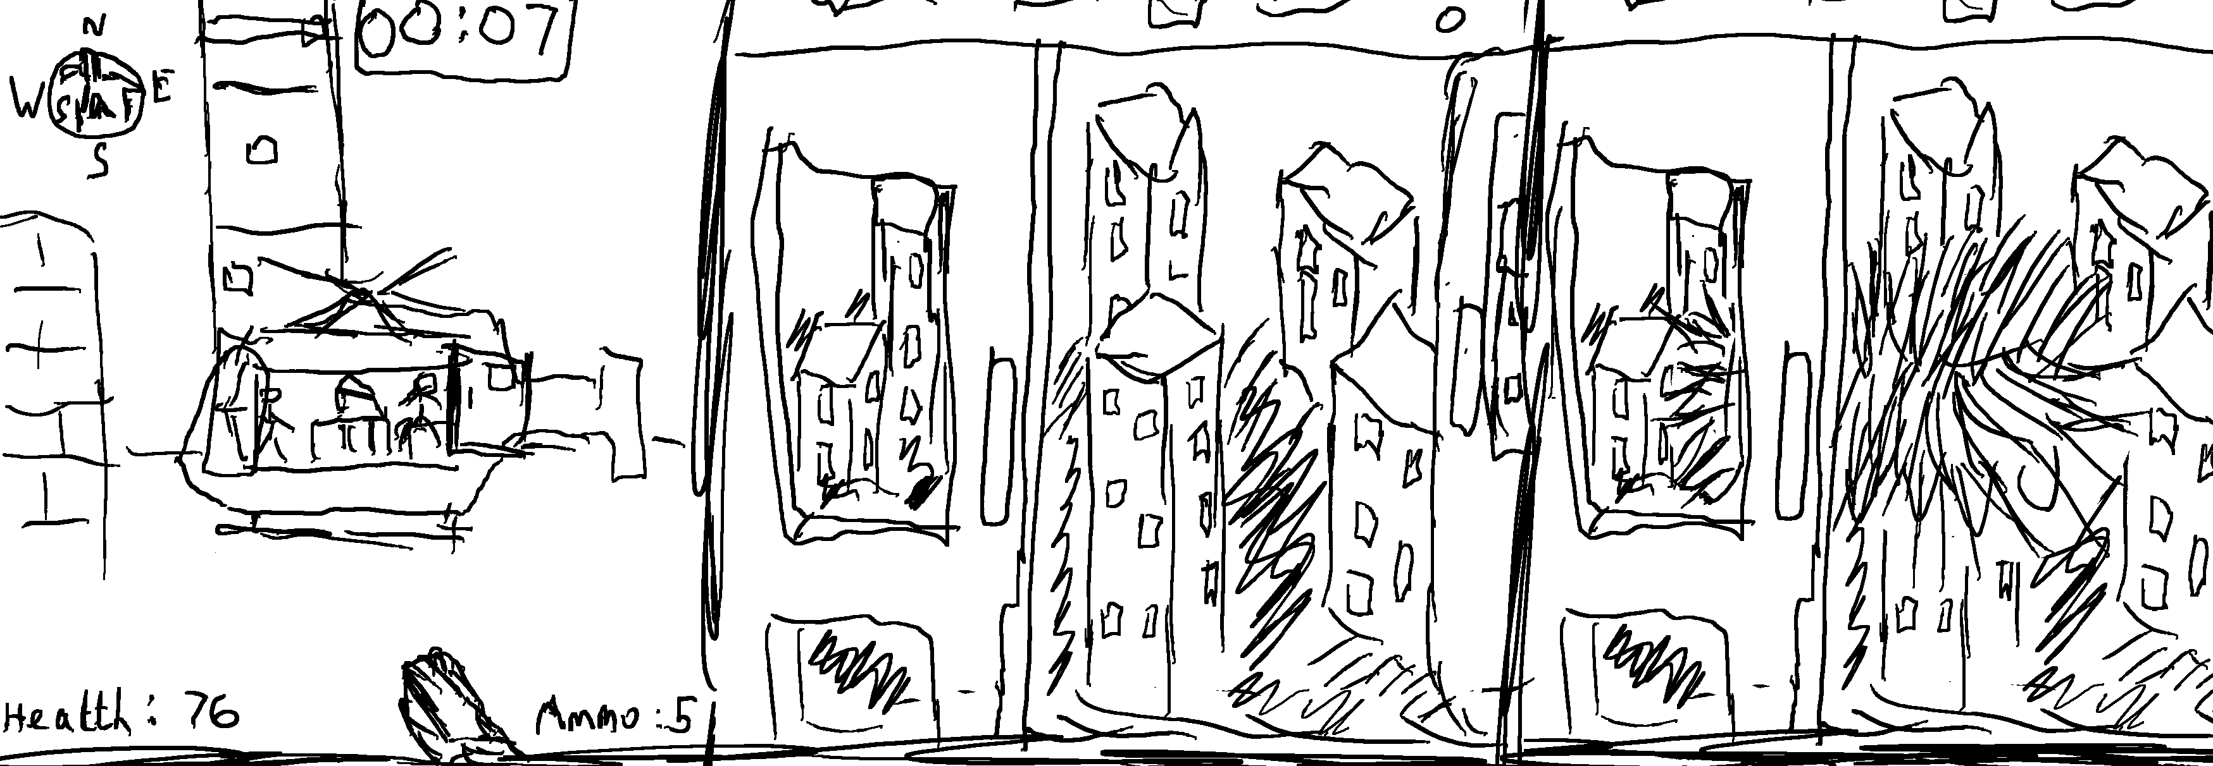

**Storyboard of final cutscene, where player makes it to the helicopter, the helicopter takes off over the city and the player gets to watch the detonation of the city from the sky.**

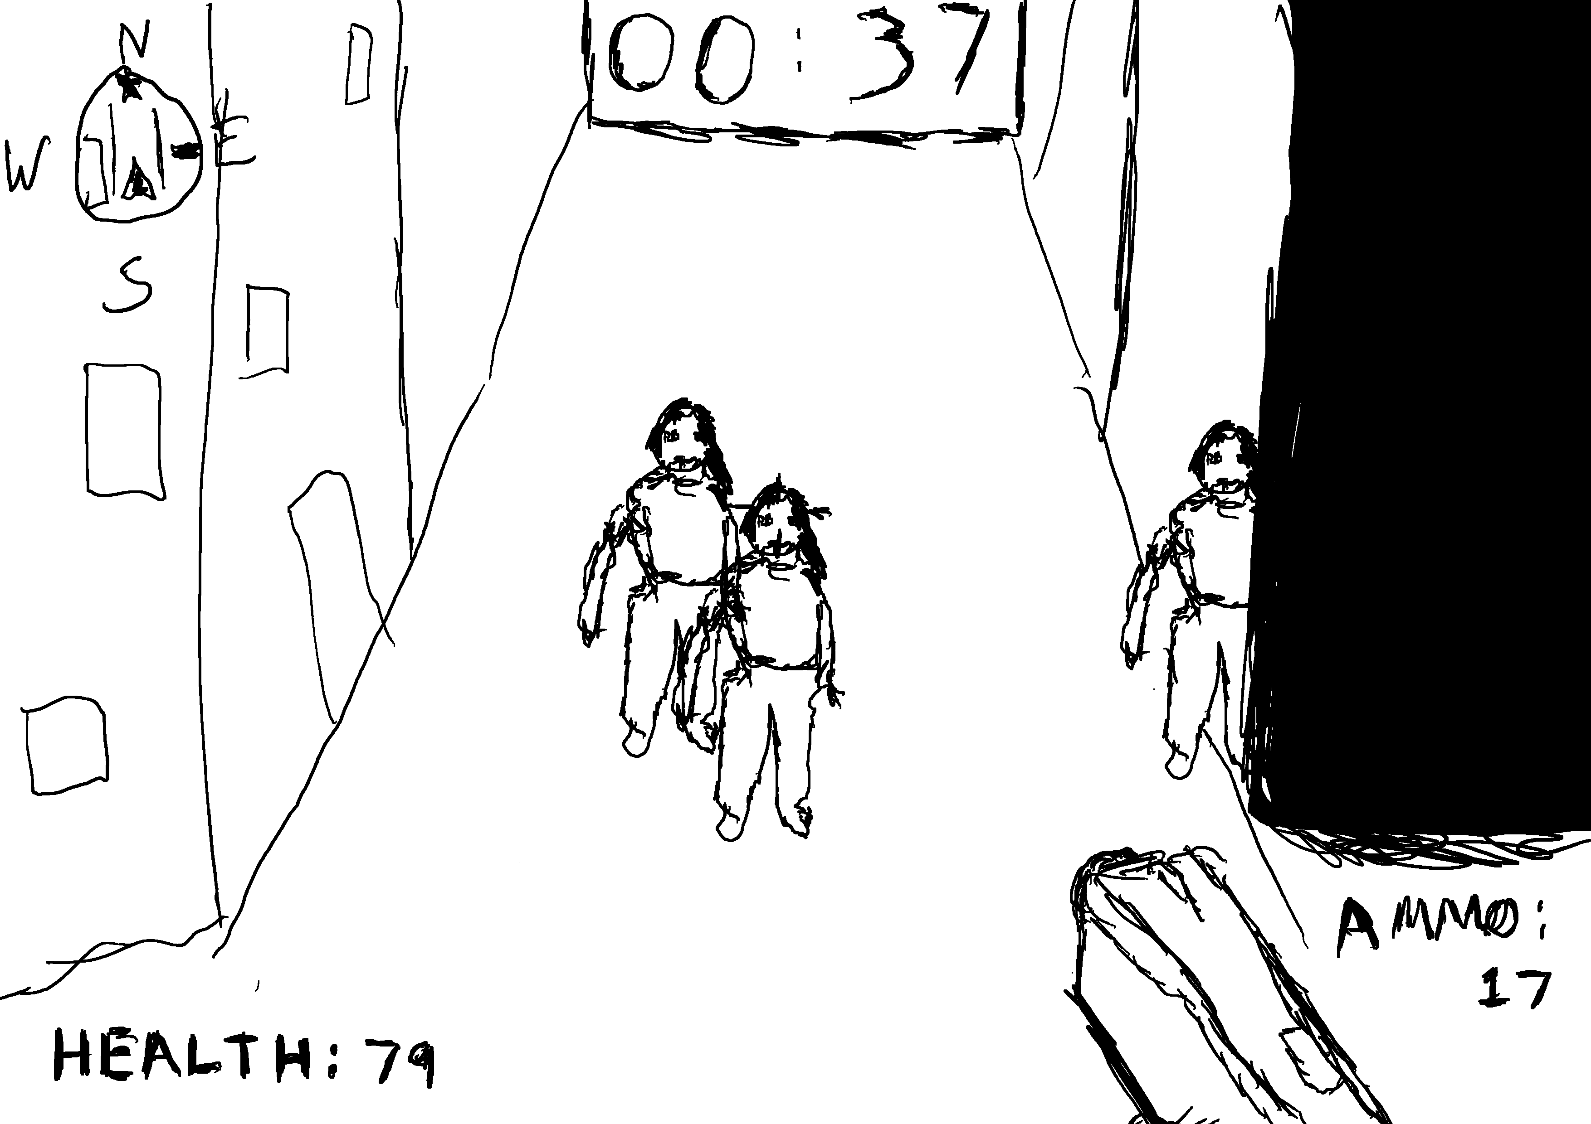

**A basic sketch on how the gameplay and HUD might look in the game.**

**6. Music and Sounds**

There will be an intense underlying track to the game as the player plays through the level. This music will change as the timer draws to an end, becoming even faster paced and intense to get across to the player that it’s time to hurry.

I plan to implement some ambient sounds throughout the level to hopefully keep them on their toes.

**7. Demographics**

The audience I plan to make this game for would be anyone from the ages 12-25 years with an interest in the zombie FPS genre of games.

**8. Platforms**

I plan to make this game available only on PC, as it is the easiest with my available tools.